StoryScript tutorial

Setting up Visual Studio Code
To work with StoryScript effectively, you should use an editor that supports you in creating your game components like HTML and TypeScript files. A good choice is Visual Studio Code. This is a product related to the full-fledged Visual Studio, but much more lightweight and, more important, also available on operating systems other than Microsoft Windows. Of course, you can also use the full Visual Studio if you want.
This tutorial will assume you are using Visual Studio Code, and it will help you set it up for Windows. The first step is to download and install it. Go to https://code.visualstudio.com/download and download and install the program (the default settings are fine if you are unsure what to choose when you are presented with options).
Once done, you will also need to install NodeJs to be able to build and run your game. Download it from https://nodejs.org/en/ and run the installer. Once done, run the following command in the command promt: npm install -g gulp. To access the command prompt, click the windows button in the lower left corner of your desktop and type 'cmd' to have it appear. Right-click it and choose 'Run as administrator':
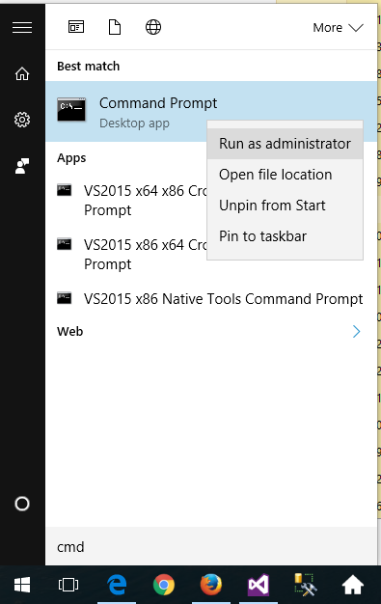
Now that you have your development environment set up, it is time to get the StoryScript code from GitHub. Navigate to https://github.com/StrixIT/StoryScript, click 'clone or download' and click the 'Open in Desktop' button:
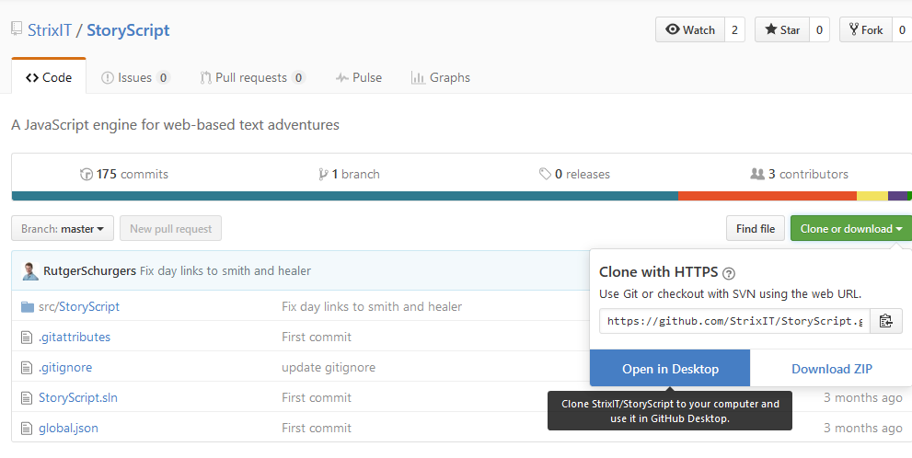
You will be redirected to the GitHub desktop website. Download and install GitHub desktop and start the program. Use the '+' in the top left corner to go and select the StoryScript repository and clone it to your computer:
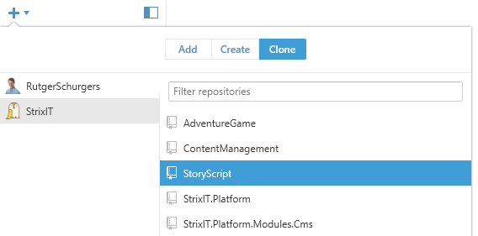
Select a folder to clone to and press ok. Once cloning is done, you are ready to start Visual Studio Code.
From within Code, open the subfolder 'src/StoryScript' from the folder you cloned StoryScript to via File → Open folder:
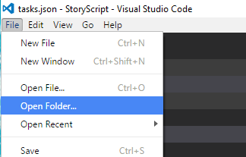
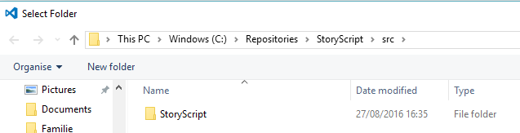
You should see the StoryScript folder open in your explorer on the right:
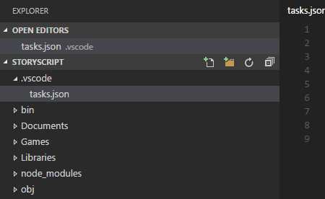
Great, now just one more step before you are all set up! You need to install a web server to be able to test and play your game. Open a command prompt again and use the command 'npm install -g lite-server' to install lite-server.
Now, you can finally start working on your game!

Creating a new, empty game
To start working on a new StoryScript game, first choose a name for it, without spaces or special characters. Let's use MyNewGame as an example.
Navigate to the Games folder, right-click the _GameTemplate folder and choose copy:
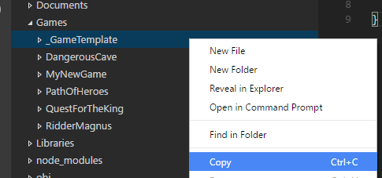
Right-click the Games folder and choose paste. Then rename the _GameTemplate – Copy folder that was created to your game name, so MyNewGame.
The next step is to move all files to your game namespace. Open all .ts files in your new folder and change the first line of all files from 'module GameTemplate' to 'module MyNewGame'. Note that in Visual Studio (the full version) the 'Start.ts' file is hidden under the 'Start.html'. Click the triangle in front of the .html file to display it.
In the game.ts file located in the interfaces folder, change the line:
storyScriptModule.value("gameNameSpace", 'GameTemplate');
to:
storyScriptModule.value("gameNameSpace", 'MyNewGame');
Finally, open the gulpfile.js file in the root of the StoryScript project, copy the line:
gulp.task('build-game-template', ['delete-files'], buildGame('_GameTemplate'));
and change the copy to:
gulp.task('build-my-new-game', ['delete-files'], buildGame('MyNewGame'));
You should now have a new build for your new game. In the full version of visual studio, you can use the task runner explorer to start your build task by double-clicking build-my-new-game. In Code, press 'SHIFT-CONTROL-P' to bring up the command pallette and type 'task'. Then, select 'run task' from the menu:
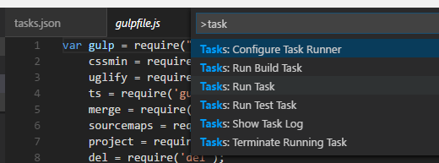
and then select your build:
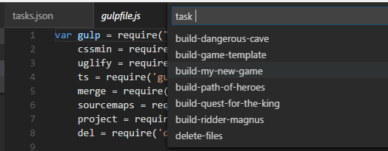
If you get no errors, run the project by navigating to the wwwroot folder using your command prompt and typing 'lite-server':

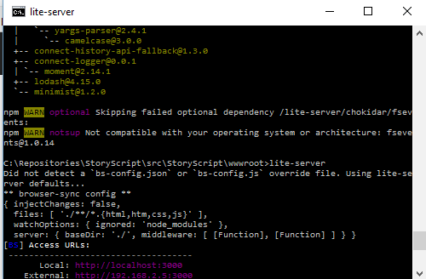
Your preferred browser should launch, showing you something like this:
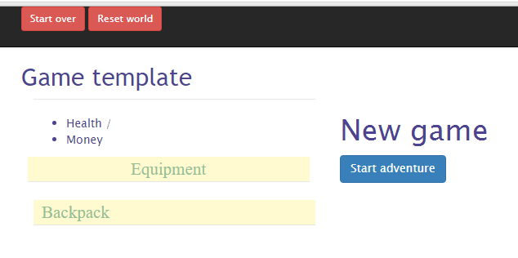
Congratulations, you are ready to begin creating your new game!

Define your hero
Next, you want to let the player create a hero with whom to play the game. To determine what such a hero looks like, open the character.ts file in your game's folder. You can add properties where it says so. Say we want to measure our hero's strength, agility and intelligence, which start at 1 and max out at 10 (we do not do anything to enforce that yet). We then add:
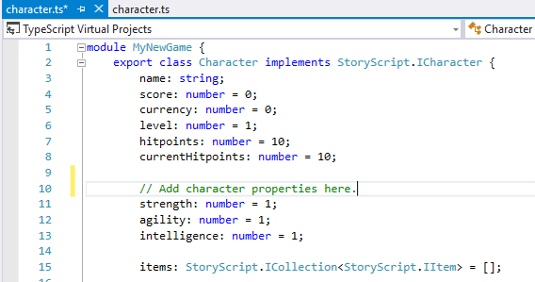
Next, we need to choose the equipment slots that we will use. You can enable these slots (the list can be reviewed in the StoryScript folder, character.ts file):
head, body, hands, leftHand, leftRing, rightHand, rightRing, legs, feet.
Let's use head, body, left and right hands and feet only. We define this by populating the character's equipment object like this:
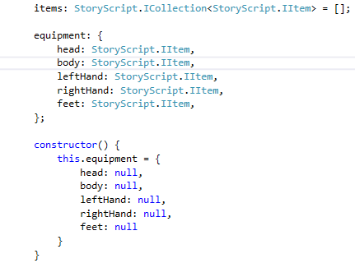
Now, we want the player to make some choices when creating the hero that will determine his or her starting stats. For this we need to define the character creation process. Open the ruleService.ts file in your game's folder and find the line that says “Add the character creation steps here”. We will ask the player what name he wants to give to his character and ask two questions, showing the second question only after he answered the first. To do that, we'll create three steps (if we wanted to show both questions at the same time, we would define only two steps, one for the name and one containing both questions). The required code is listed below:
getCreateCharacterSheet = (): StoryScript.ICreateCharacter => {
return {
steps: [
{
attributes: [
{
question: 'What is your name?',
entries: [
{
attribute: 'name'
}
]
}
]
},
{
questions: [
{
question: 'As a child, you were always...',
entries: [
{
text: 'strong in fights',
value: 'strength',
bonus: 1
},
{
text: 'a fast runner',
value: 'agility',
bonus: 1
},
{
text: 'a curious reader',
value: 'intelligence',
bonus: 1
}
]
}
]
},
{
questions: [
{
question: 'When time came to become an apprentice, you chose to...',
entries: [
{
text: 'become a guard',
value: 'strength',
bonus: 1
},
{
text: 'learn about locks',
value: 'agility',
bonus: 1
},
{
text: 'go to magic school',
value: 'intelligence',
bonus: 1
}
]
}
]
}
]
};
}

Save all files, run the build-my-new-game again, and refresh your browser using F5. After entering a name, you should see the first question with the three options you defined:

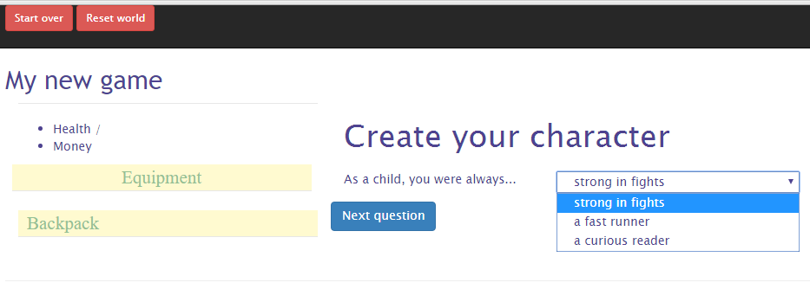

Personalize the interface texts
Now is a good time to change some of the interface texts you are seeing. For example, the display name of your game is still 'Game template', and maybe we want to show 'Create your character' instead of 'New game'. There are three ways in which you can change the interface, and changing just the texts is easy and done via the customTexts.ts file in your game folder. The other ways are changing the game styling and customizing display templates, both of which are discussed later in this document.
Open your customTexts.ts file, place your cursor one line below where it says 'Add your custom texts here' and press CONTROL-SPACE. You will now see a list of all the texts that you can personalize:
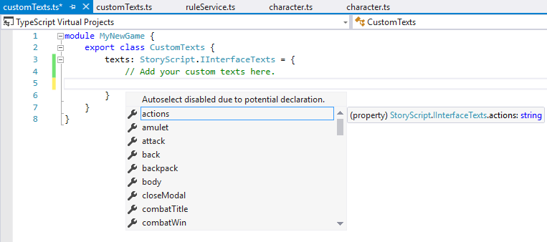
Change the game name and new game texts by adding the following code:
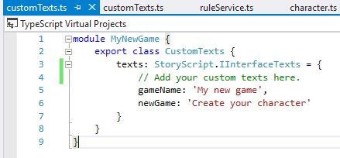
Run the build-my-new-game again, and refresh your browser using F5 to see your new texts displayed.

Locations

Change a location's name and description
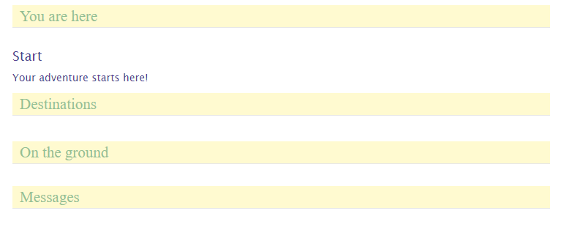
When we create our character, there's nothing for us to do right now. Our adventure window shows very little:
First, you can change the text displayed under 'You are here' by modifying your currenty only location, Start. Open the locations folder under your game folder and you will see a Start.html file with a start.ts file underneath:
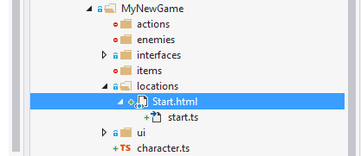
To change the 'Start' text, open the start.ts file and change the name property in the file, for example to 'Home'. The description of the location ('Your adventure starts here') is in the Start.html file. In that file, you can see a <description> tag containing the text. Let's change it to 'You are at home. Let's get started.'
Run your build and refresh your browser. Press the 'Reset world' button in the top menu. You should now see:
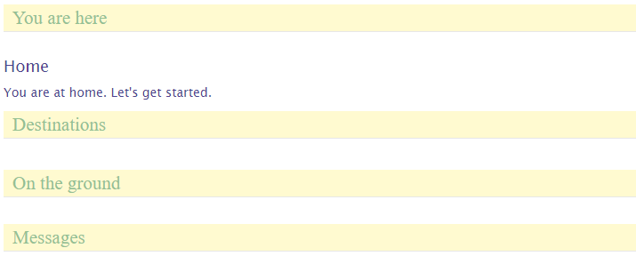

Multiple descriptions for varying circumstances
A nice feature is that you can have multiple descriptions in a location's .html file that you can choose from while running the game. As an example, let's make it so that the location description changes depending on the time of day, with a text for daytime and a text for night time. To do this, you need to repeat the <description> tag and add an attribute to the second tag that you will use to select it, for example 'night'. Our Start.html will then look like this:
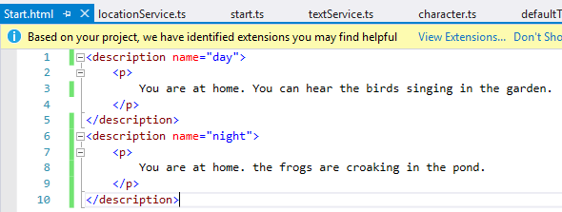
To actually show the night time description between 6 p.m. And 6 a.m., we need to create a selector in our location's .ts file. Modify your start.ts like this:
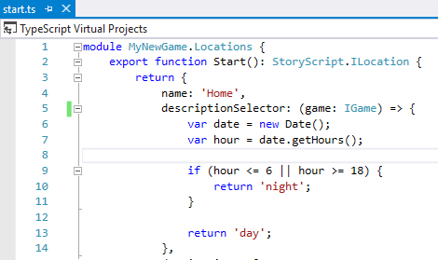

Now, depending on your local time, you see either:
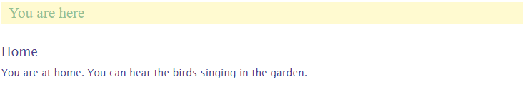
Or:
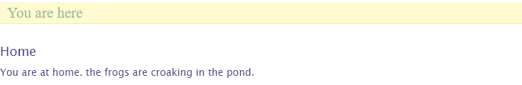

Adding new locations
Now that we are happy with our start location, let's allow the player to go somewhere. We'll add to new locations, the hero's garden behind his home and the dirt road in front of it. The easiest way to do so is just to copy Start.html twice and rename the copies. The result should look like this:
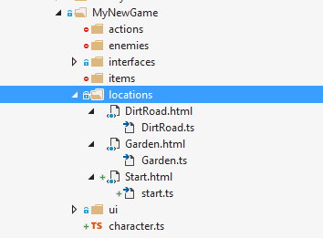
Open both the new .ts files, change the name properties and remove the description selectors. Also change the function names to match the file names (not required, you can select another name as long as it does not have spaces or special characters). Your Garden.ts should look like this:

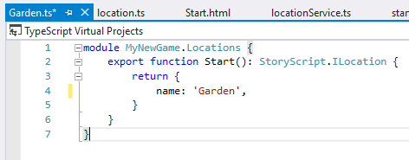
And your DirtRoad.ts similar, with a different name and function name of course.
Next, change your .html files to add some proper descriptions. We use just one description for now, so please remove the name attribute from the description tag. My Garden.html looks like this:
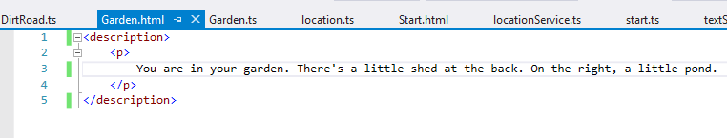

Linking locations
Allright, now we have three locations but no way to reach the new locations yet. To connect locations, open a location's .ts file and add a destinations property. We'll do so in the Start.ts file. The player should be able to go to the garden or the dirt road from the start location.
Start by adding a destinations array and a first destination object. A destination has a text (this is shown in the interface under the destinations header) and a target, the actual destination. Note that when you create the target and you typed Locations and entered the dot, visual studio will show you all your locations so you can easily pick the one you want:
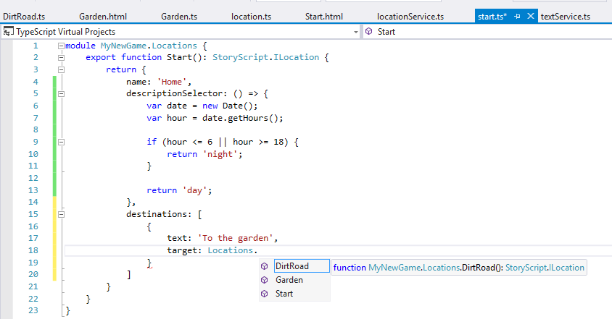
When you added both destinations, your destinations code looks something like this:
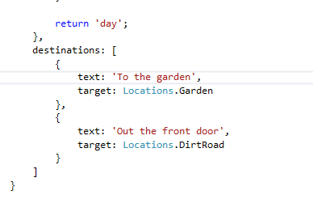
Build the game, refresh the browser and click 'Reset world'. You now should see this:
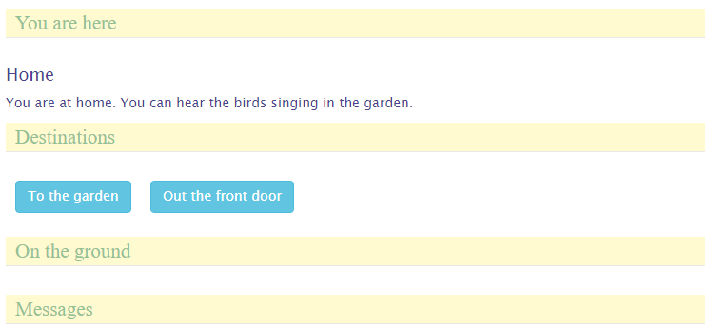
Clicking one of the buttons should take you to that location. Note that now you are stuck because you have not defined the navigation the other way around. Do that, click 'Start over' and walk around your three-stage world.

Items
Going out there without decent gear will cut any adventuring career short. Let's add some basic items for our hero to pick up at his home. Add two new .ts files to the items folder in your game folder. You can do that by right-clicking the items folder and selecting Add → new item. Select client-side and then TypeScript file:
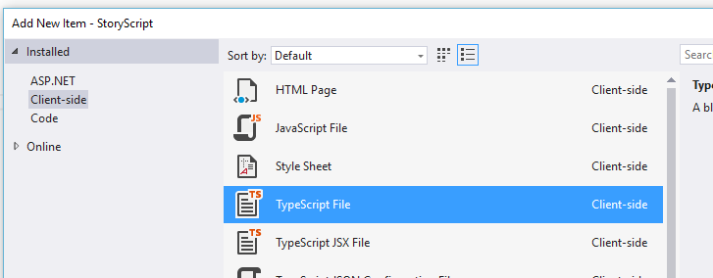

Add sword.ts and leatherBoots.ts. They should look like this:

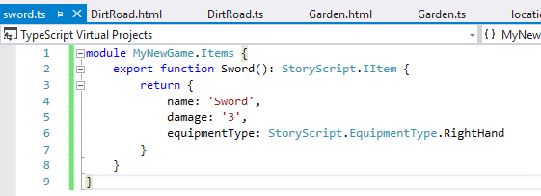
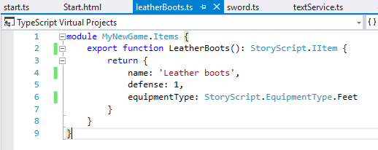
Ok, now that we have the items, we need to make them available. Add them both to the starting location by modifying your Start.ts, like so:

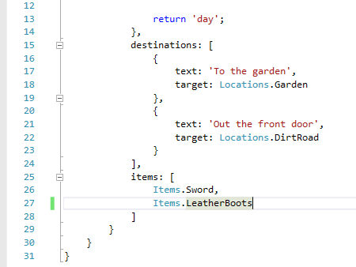
Build your game, refresh the browser and click 'Reset world'. When you go to your home, you should see:
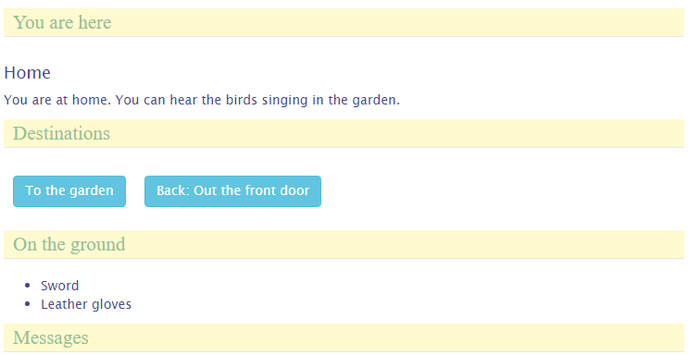
You can pick up these items by clicking them, and you can then equip them or drop them again.

Events
Let's now enhance our walking around experience a bit by adding an event to our garden. Events are anything you can think of that happen once, when the player first enters a new location. We'll do something very simple and just write a message to the log. Modify your Garden.ts like this:
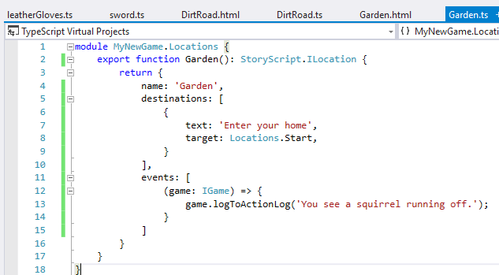
Build, refresh, and reset. Go to the garden. The first time you go there (and first time only), you should see the message appearing under 'Messages':
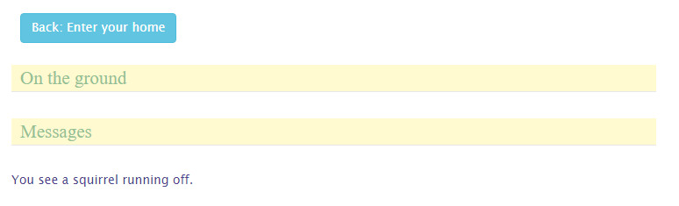
This is of course rather trivial, but events can be used for powerful stuff as you have the full game API at your disposal in the event function. Check out the API documentation once you feel comfortable enough with the StoryScript concepts described in this tutorial.

Enemies
Let's give the hero an opportunity to be heroic by adding a bandit to the dirt road which he can fight. First, add a new bandit.ts file to the enemies folder in your game folder. It should look like this:
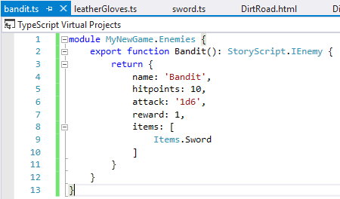
Note that I gave the bandit a sword, just like the one our hero can pick up at home. When an enemy is defeated, the items he carries are dropped on the floor in that location.
Now, we need to add the bandit to the dirt road location. Modify DirtRoad.ts like this:
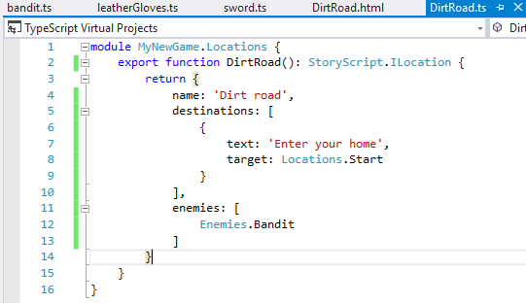
Build, refresh and reset. You should see the bandit as you enter the dirt road:
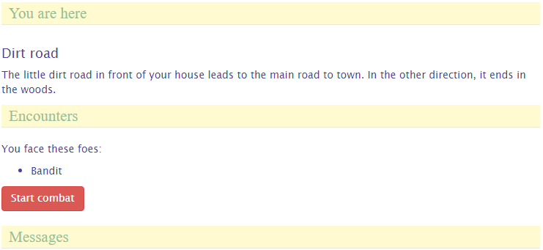

Creating a combat system
When you enter combat and click the Attack Bandit button, nothing happens. That's because there is no default combat system in StoryScript, as combat rules as well as how heroes, enemies and items are defined can vary wildly. You will have to program such a system yourself, which requires some skill with JavaScript and TypeScript.
For now, let's just add a very simple system to experiment with. Open your ruleService.ts and find the fight method, shown below:
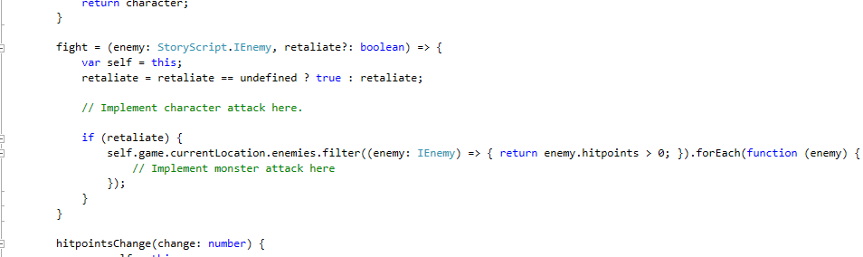
Modify it like this:
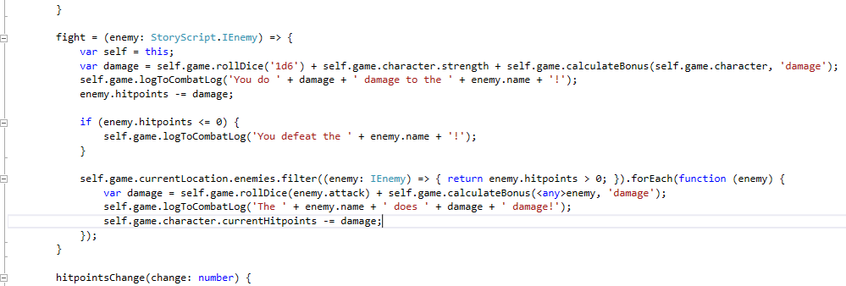
This combat system is very simple. It just rolls a six-sided die for the hero and adds his strength and weapons damage bonus to the result. It writes a message to show the damage done, and subtracts the result from the enemy's hitpoints. When the enemy has 0 or less hitpoints, another message is written and the method exits, returning true for winning combat. If not, the enemy attacks the player in the same way.
Build, refresh, reset and click Attack bandit. You can't lose yet, so after a few clicks the bandit will be defeated and you see something like this:
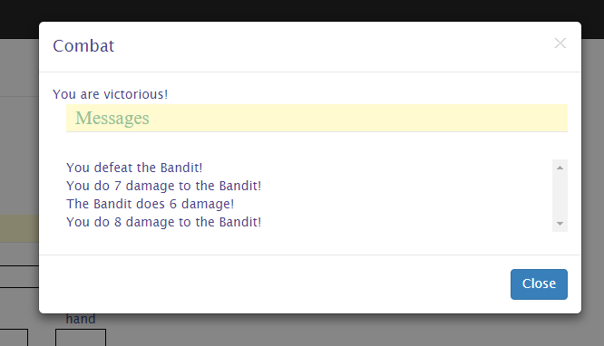
When you click 'Close', notice that the Bandit's sword is now lying on the ground:
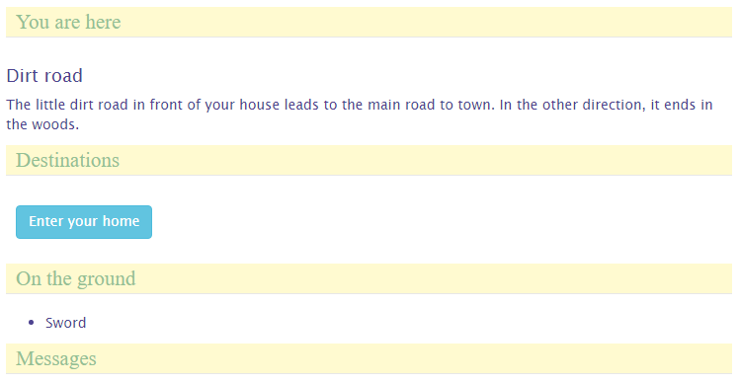
Now to make it a fair fight, go back to the ruleService.ts and implement the hitpointsChange method like this:
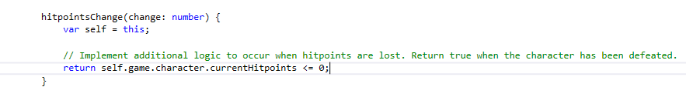
Build, refresh and start over. Go out there and attack again. You might win again, or you might not:
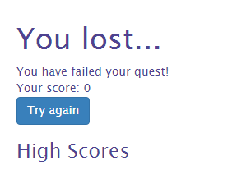

Actions and CombatActions
For the game locations to become interesting, they should offer more than only enemies and events. There should be things to do, buttons to push. That's where actions come in. When you define actions, these will be available at the location after all enemies have been defeated. Examples of actions you might want to add are search, to find more items when the character is alert enough, opening chests, etc.
Let's add two actions to the garden, one to search the shed and one to look in the pond. Add this code to Garden.ts:
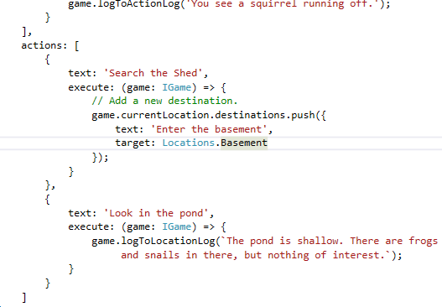

Note that I had to add the Basement location to be able to add the new destination. If you are following along, add that location too.
Build, refresh and reset, and you should see the following in the garden:
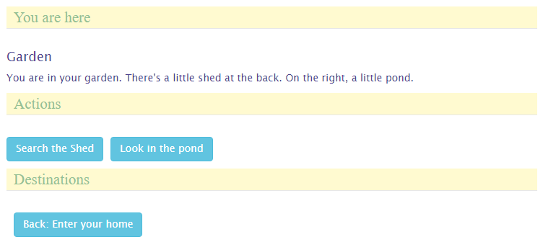
When you press the Search button, a new destination will be added and the Search button removed. Look in the pond will remove the action and write to the location description. If you want to keep the button when it is clicked, have the action's execute method return true (check out the API).
Combat actions are like actions but are available during combat only, when regular actions are not available. Let's allow the hero to run back home when he is afraid to stand up to the bandit. Add this code to DirtRoad.ts:
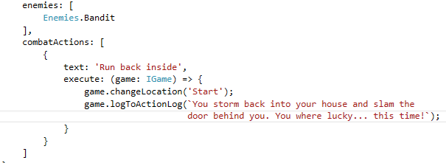
When you go out the door to face the bandit, you should see the option to run back inside. When you take it, you will be told you ran away:
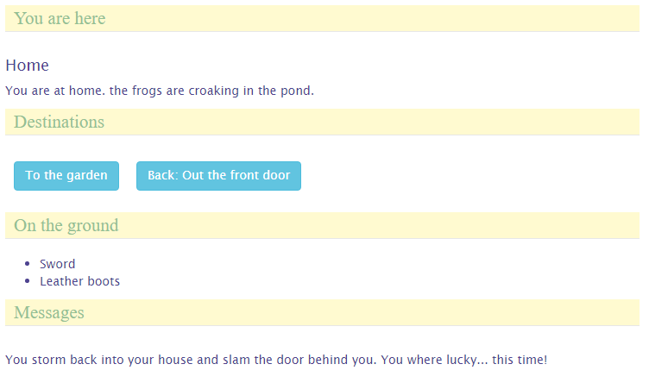

Doors, gates, rivers and other barriers
To make the world more interesting and locations less easy to reach, you can add barriers that impede the hero's progress. Barriers can be anything from doors, locked gates, rivers, chasms or even leaving the atmosphere of a planet.
Barriers are added to destinations, so that it is not simply a matter of moving from one location to the next by pressing a button anymore. As an example, let's add a trap door as a barrier between the garden and the shed basement. Let's leave it unlocked for now, we'll add a required key later.
Open the Garden.ts file and add the following barrier code to the Basement destination:
TODO

Conversations
TODO

Trade and storage
TODO

Adding media
As StoryScript uses HTML and JavaScript for its interface, you can use any media that will work with these technologies in your game. For descriptions, which are plain HTML files, it is easiest. For example, find yourself a picture you want to add and place it in the resources folder of your game folder. Then, in your Start.html, include the following HTML-tag:
<img src=”resources/mypicture.jpg” />
Build and refresh, and when your hero is at home you should see your picture shown.
You can also add images to enemies and items, though item pictures are not displayed yet. To add an image to the bandit, open the Bandit.ts file and add the pictureFileName property like this:
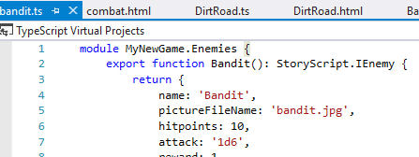
The bandit.jpg file needs to be present in the resources folder as well. Adding images to items works in the same way.
Build, refresh and reset and go out on the road. The bad guy should now have a face!

API
TODO

